**TABLE: GRADUATE**

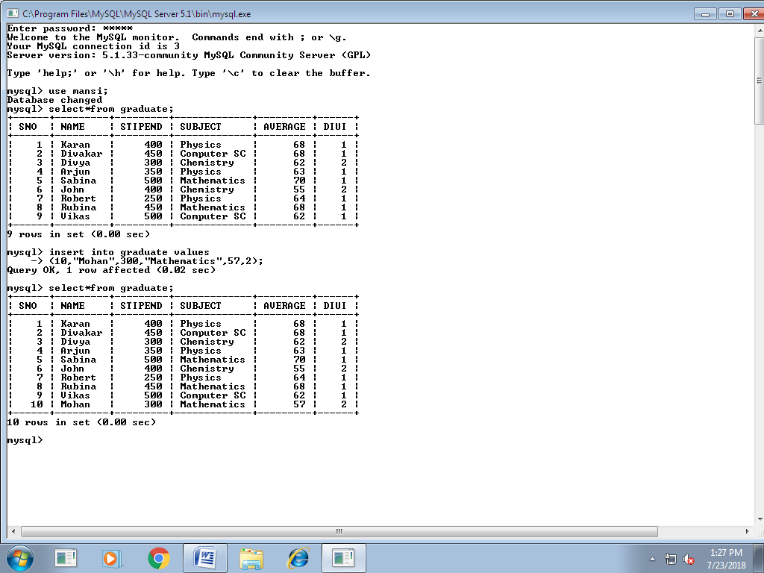

**QUERIES:**

1. List the names of those students who have obtained DIVI=1 sorted by NAME.
2. Display the report, listing NAME, STIPEND, SUBJECT and amount of stipend received in a year assuming that the STIPEND is paid every month.
3. To count the number of student who are either PHYSICS or COMPUTER SC graduate.
4. To insert a new row in the GRADUATE table:

“11,’KAJOL’,300,’COMPUTER SC’,75,1”.

**1**

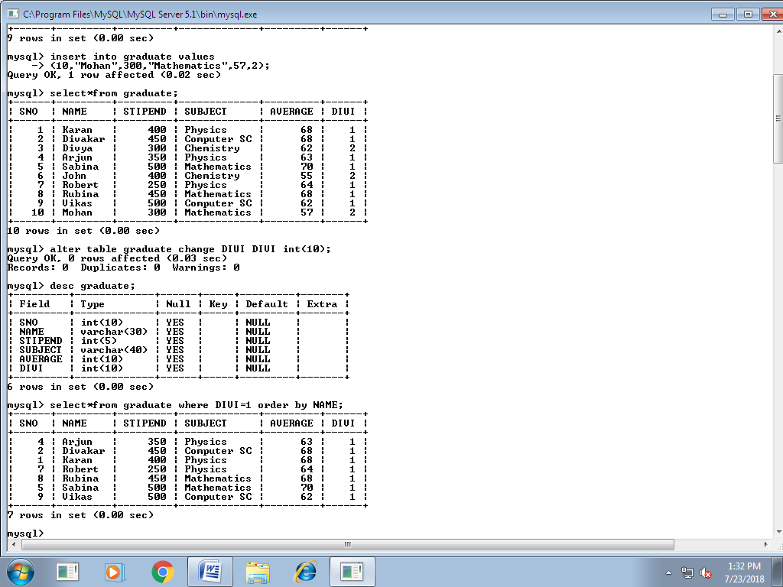

**2**

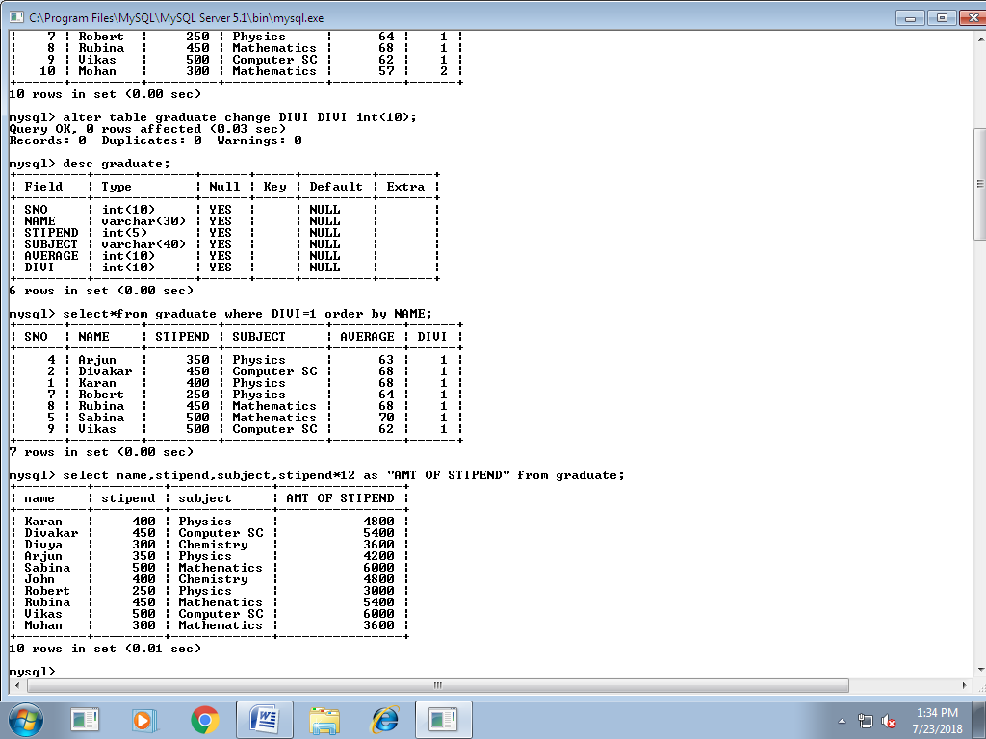

**3**

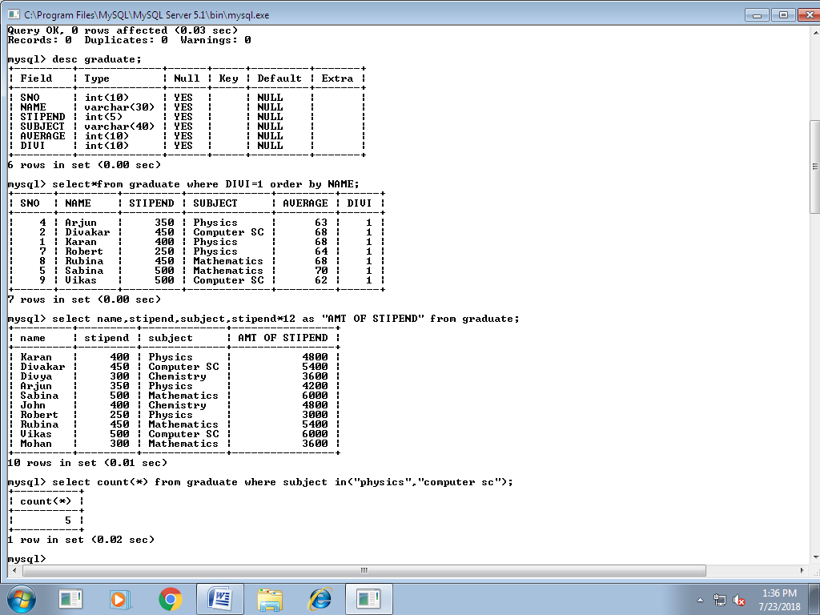

**4**

